Gasser Ahmed

[gasser18@vt.edu](mailto:gasser18@vt.edu)

ECE 5484, Homework 7

1. That’s because TCP segment must fit in IP packet, so the TCP module adjusts the maximum size of the TCP segment, which must be less than 65536 bytes or limited to 65,535 bytes. The TCP segment requires 20 bytes for the header at the beginning of each segment and that leaves 65115 bytes for the length of the segment for it to be able to fit into an IP payload. That is, no particular segment can be larger than 65536 bytes because the sequence number of each transmitted byte is stored in a 32-bit field in the TCP header.
2. a. TCP and IP headers consist both of 20 bytes = 40 bytes for overhead. 2048 bytes divided by the four segments will equal (40 + 512) * 4 = 2208 bytes that will have to fit in these four segments. Since we have a total of 40*4 = 160 bytes of overhead.

Therefore, percentage of protocol overhead = 160 / 2208 * 100% = 7.25%

b. For IPv6, TCP header (40 bytes) + IP header (20 bytes) = 60 bytes, therefore similarly as ‘a’,

(60 + 512) * 4 = 2288 bytes. Since we have a total of 60*4 = 240 bytes of overhead.

Therefore, percentage of protocol overhead = 240 / 2288 * 100% = 10.5%

1. a. Bytes 1000 through 1099

b. Byte 2999

1. Router 4

|  |  |  |
| --- | --- | --- |
| Dest | Next Hop | Hop Count |
| A | R3 | 1 |
| B | -- | 0 |
| C | R1 or R3 | 2 |
| D | -- | 0 |
| L | R1 | 1 |
| M | R1 | 1 |
| N | R1 | 1 |
| R | R1 or R3 | 2 |
| T | R3 | 1 |
| W | R3 | 1 |

1. a. In the second segment from Host A to B, the sequence number is 289 (249 + 40), source port number is 503 and destination port number is 80.

b. If the first segment arrives before the second, in the acknowledgement of the first arriving

segment, the acknowledgement number is 289, the source port number is 80 and the

destination port number is 503.

c. If the second segment arrives before the first segment, in the acknowledgement of the first

arriving segment, the acknowledgement number is 249, indicating that it is still waiting for bytes

249 and onwards.

1. a. 129.57.0.0 / 16

11111111 11111111 0 0

255.255.0.0

2^16 / 2^10 = 2^6, therefore left most 6 bits also don’t change.

Therefore, 11111111 11111111 11111111 11000000 = 255.255.255.192

b. The remaining bits must be used for the address in each subnet i.e. there will be 32 - 26 = 6 bits available for the address component. Therefore, there will be a total of 2^6=64 = 64 bits available. Therefore, the maximum number of addresses in each subnet is 64 addresses.

c. Since:

First address in subnet 0 = 129.57.0.0

Last address is subnet 0 = 129.57.0.63

Therefore:

First address in subnet 1 = 129.57.0.64

Last address is subnet 1 = 129.57.0.127

1. a. 255.255.255.0 = 11111111.11111111.11111111.00000000 = 24 consecutive 1s = /24

b. 255.255.240.0 = 11111111.11111111.11110000.00000000 = 20 consecutive 1s = /20

1. a. 123.56.77.32/29

Smallest: 01111011. 00111000. 01001101. 00100 000 = 123.56.77.32

Largest: 01111011. 00111000. 01001101. 00100 111 = 123.56.77.39

b. 17.34.16.0/23

Smallest: 00010001. 00100010. 0001000 0.00000000 = 17.34.16.0

Largest: 00010001. 00100010. 0001000 1.11111111 = 17.34.17.255

1. a. Readiness score: 10/10

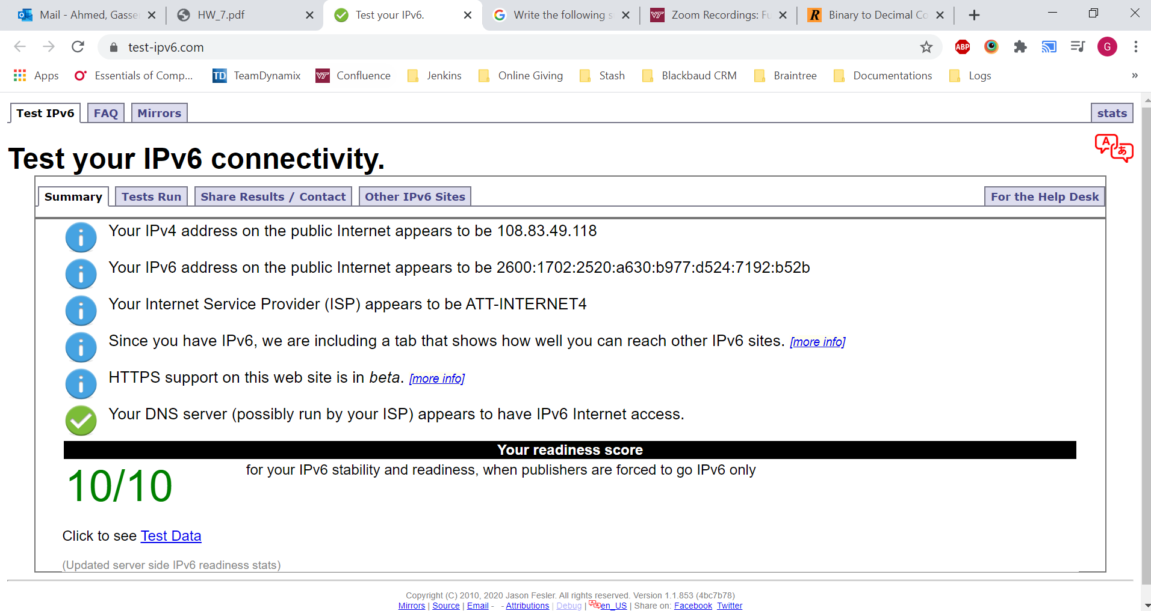

b. N/A since the readiness score is 10/10

c.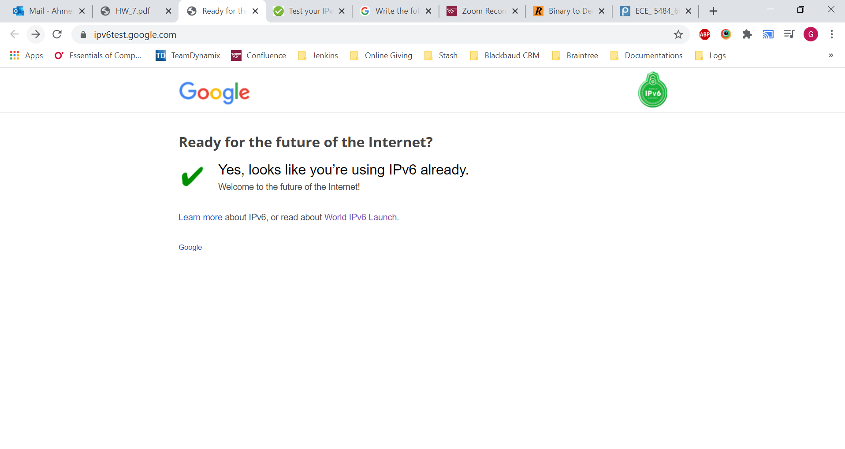

1. The subject of RFC 7511 is Scenic Routing for IPv6. It was issued on April 1st, 2015.